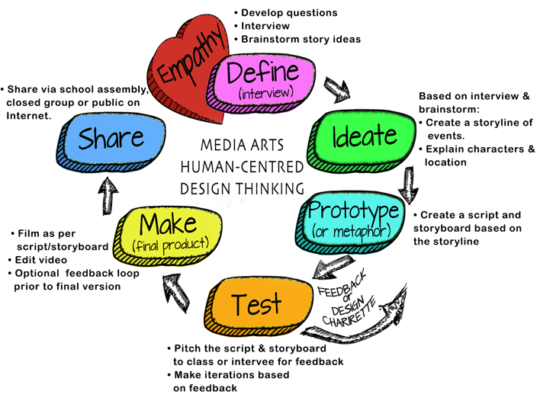
Topic:
Teacher Name:
Grade:

How will you work on building Collaborative Teams?
- Media Arts 6-9 webpage:
  - Media Arts Team Roles (all team members will be involved with the storyline, script, storyboard, filming & editing). View the for possible team roles, based on a team of 3. File:
  - Team Contracts and Project Management Logs

ADST Curricular Competencies interwoven throughout:
Applied Skills
- Demonstrate an awareness of precautionary and emergency safety procedures in both physical and digital environments
- Identify and evaluate the skills and skill levels needed, individually
or as a group, in relation to a specific task, and develop them as needed

Applied Technologies
- Select, and as needed learn about, appropriate tools and technologies to extend their capability to complete a task
- Identify the personal, social, and environmental impacts, including unintended negative consequences, of the choices they make about technology use
- Identify how the land, natural resources, and culture influence the development and use of tools and technologies

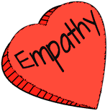 | EMPATHY: Understanding Context. Deciding who to interview depends on the intent of the video. Is the video created ABOUT a person or group? (they are the content) or FOR a person or group? (they are the audience)
ADST Curricular Competencies | - Empathize with potential users to find issues and uncover needs and potential design opportunities  - Elaborations: share the feelings and understand the needs of others to inform design
ADST Content | MEDIA ARTS (If filming interview)  - issues in ethical media practices, including cultural appropriation, moral copyright, reproduction, and privacy
Additional Curriculum:  ENGLISH LANGUAGE ARTS | COMPETENCIES: COMPREHEND AND CONNECT  - Access information and ideas for diverse purposes and from a variety of sources and evaluate their relevance, accuracy, and reliability  COMPETENCIES: CREATE AND COMMUNICATE  - Use writing and design processes to plan, develop, and create engaging and meaningful literary and informational texts for a variety of purposes and audiences
Additional Curriculum:

Instruction/ Just in time learning | - Developing interview questions  - How to film an interview
Formative Assessment
Materials Needed | Media Arts 6-9 Website  - Questioning/Interviewing  - Tips for Shooting an Interview:
Teacher Reflection

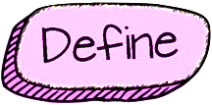 | DEFINE: Teams will review interview answers/footage and brainstorm/determine ideas regarding film genre and story.
ADST Curricular Competencies | - Choose a design opportunity  - Identify key features or potential users and their requirements  - Identify criteria for success and any constraints
ADST Content | MEDIA ARTS  - influences of digital media for the purpose of communication and self-expression
Additional Curriculum:  ENGLISH LANGUAGE ARTS | COMPETENCIES: COMPREHEND AND CONNECT  - Understand how literary elements, techniques, and devices enhance and shape meaning  COMPETENCIES: CREATE AND COMMUNICATE  - Use writing and design processes to plan, develop, and create engaging and meaningful literary and informational texts for a variety of purposes and audiences
Additional Curriculum:

Instruction/ Just in time learning | ​​  - Basic plots & conflicts  - How to use the graphic organizer to determine the key features from the interview  - What are genres?  - Video: Shrek but in 7 Different Genres ​ (on Media Arts 6-9 website)
Formative Assessment
Materials Needed | Media Arts 6-9 Website  - Basic plots & conflicts  - Brainstorming graphic organizer
Teacher Reflection

 | IDEATE: Teams will develop a storyline considering setting, characters, and story events. If the video includes dialogue, students will create a script based on the storyboard. Students will learn/review shot styles, angles and camera motion
ADST Curricular Competencies | - Generate potential ideas and add to others’ ideas  - Screen ideas against criteria and constraints  - Evaluate personal, social, and environmental impacts and ethical considerations  - Choose an idea to pursue
ADST Content | MEDIA ARTS  - digital and non-digital media, and their distinguishing characteristics and uses
Additional Curriculum:  ENGLISH LANGUAGE ARTS | COMPETENCIES: COMPREHEND AND CONNECT  - Recognize and appreciate the role of story, narrative, and oral tradition in expressing First Peoples perspectives, values, beliefs, and points of view  - Select and use appropriate features, forms, and genres according to audience, purpose,  and message  - Use and experiment with oral storytelling processes  CONTENT: STORY/TEXT:  - forms, functions, and genres of text  COMPETENCIES: CREATE AND COMMUNICATE  - Use writing and design processes to plan, develop, and create engaging and meaningful literary and informational texts for a variety of purposes and audiences
Additional Curriculum:

Instruction/ Just in time learning | Media Arts 6-9 Website  - Shot styles  - How to create a storyline  - How to write a script (not needed for an iMovie trailer)
Formative Assessment | - Share first draft of storyline with another team for feedback  - Reflective journal entry on participation
Materials Needed | Media Arts 6-9 Website  - Video examples of various genres for writing styles (under the Define heading on the website)  - Storyline  - Optional: Script writing tool (browser based)
Teacher Reflection

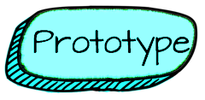 | PROTOTYPE: Teams will storyboard their storyline, including shot style, camera angle, camera person, talent.
ADST Curricular Competencies | - Identify and use sources of information  - Develop a plan that identifies key stages and resources  - Explore and test a variety of materials for effective use  - Construct a first version of the product or a prototype, as appropriate, making changes to tools, materials, and procedures as needed  - Record iterations of prototyping
ADST Content | MEDIA ARTS  - techniques for using images, sounds, and text to communicate information, settings, ideas, and story structure
Additional Curriculum:  ENGLISH LANGUAGE ARTS | - COMPETENCY: Select and use appropriate features, forms, and genres according to audience, purpose,  and message  - COMPETENCY: Use and experiment with oral storytelling processes
Additional Curriculum:

Instruction/ Just in time learning | - Why storyboard
Formative Assessment | - Students reflect on the degree to which the storyboard follows the storyline
Materials Needed | - Completed storyline  Media Arts 6-9 Website  - Storyboards  - Storyline & Storyboarding, grade 6-7 and 8+​
Teacher Reflection

 | TEST: The Pitch: Teams will pitch to the class (or to the people they interviewed). The class or interviewee provide feedback. Teams iterate their original plan.
ADST Curricular Competencies |  | - Test the first version of the product or the prototype  - Gather peer and/or user and/or expert feedback and inspiration  - Make changes, troubleshoot, and test again
ADST Content |  | MEDIA ARTS-N/A
Additional Curriculum:  ENGLISH LANGUAGE ARTS |  | CONTENT: LANGUAGE FEATURES, STRUCTURES, AND CONVENTIONS  - presentation techniques
Additional Curriculum:

Instruction/ Just in time learning |  | - How to provide meaningful feedback
Formative Assessment |  | - Peer feedback
Materials Needed |  | Media Arts 6-9 Website  - Ideas for a Pitch  - Feedback slips for peers
Teacher Reflection

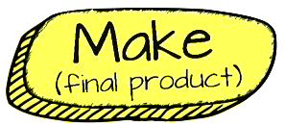 | MAKE: Teams film as per their storyboard (obtaining permission before hand where needed). Teams should rotate the camera person, and talent roles. Students will then edit with iMovie
ADST Curricular Competencies | - Identify and use appropriate tools, technologies, and materials for production  - Make a plan for production that includes key stages, and carry it out, making changes as needed  - Use materials in ways that minimize waste
ADST Content | MEDIA ARTS:  - techniques for using images, sounds, and text to communicate information, settings, ideas, and story structure  - DIGITAL LITERACY CONTENT:  - legal and ethical considerations, including creative credit and copyright, and cyberbullying
Additional Curriculum:  ENGLISH LANGUAGE ARTS | COMPETENCIES: CREATE AND COMMUNICATE  - Use writing and design processes to plan, develop, and create engaging and meaningful literary and informational texts for a variety of purposes and audiences  - Transform ideas and information to create original texts
Additional Curriculum:

Instruction/ Just in time learning | Options (on the Media Arts 6-9 Website)  - How to use “Green Screen by Do Ink” app  - How to “Airdrop”  - How to use “Documents by Readdle” App (Importance of creative commons)  - Editing in iMovie
Formative Assessment | - Individual/Team daily reflection
Materials Needed | - Film equipment  - iMovie
Teacher Reflection

 | SHARE: Student share and reflect. Sharing could be at an assembly, on the Internet or more. It is important that students have an opportunity to share their work.
ADST Curricular Competencies | - Decide on how and with whom to share their product  - Demonstrate their product and describe their process, using appropriate terminology and providing reasons for their selected solution and modifications  - Evaluate their product against their criteria and explain how it contributes to the individual, family, community, and/or environment  - Reflect on their design thinking and processes, and evaluate their ability to work effectively both as individuals and collaboratively in a group, including their ability to share and maintain an efficient co-operative work space  - Identify new design issues
ADST Content | DIGITAL LITERACY:  - methods for personal media management
Additional Curriculum:  ENGLISH LANGUAGE ARTS | CONTENT: LANGUAGE FEATURES, STRUCTURES, AND CONVENTIONS:  - presentation techniques  COMPETENCIES: CREATE AND COMMUNICATE  - Use writing and design processes to plan, develop, and create engaging and meaningful literary and informational texts for a variety of purposes and audiences
Additional Curriculum:

Instruction/ Just in time learning | - How to share to shareable space
Formative Assessment | Media Arts 6-9 Website  - Core Competencies Final Reflection
Materials Needed | - Log in to shareable space  - Discuss appropriate & private strategies for sharing and story media
Teacher Reflection

