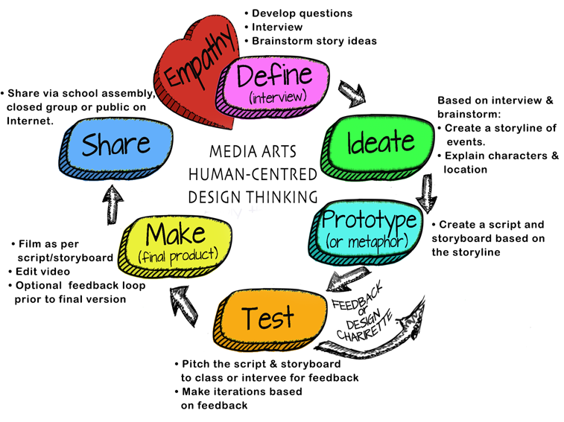
Topic:
Teacher Name:
Grade:

How will you work on building Collaborative Teams?
- Media Arts 6-9 webpage:
  - Media Arts Team Roles (all team members will be involved with the storyline, script, storyboard, filming & editing). View the for possible team roles, based on a team of 3. File:
  - Team Contracts and Project Management Logs

ADST Curricular Competencies interwoven throughout:
Applied Skills
- Demonstrate an awareness of precautionary and emergency safety procedures in both physical and digital environments
- Identify and evaluate the skills and skill levels needed, individually
or as a group, in relation to a specific task, and develop them as needed

Applied Technologies
- Select, and as needed learn about, appropriate tools and technologies to extend their capability to complete a task
- Identify the personal, social, and environmental impacts, including unintended negative consequences, of the choices they make about technology use
- Identify how the land, natural resources, and culture influence the development and use of tools and technologies

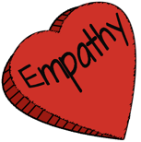 | EMPATHY: Understanding Context. Deciding who to interview depends on the intent of the video. Is the video created ABOUT a person or group? (they are the content) or FOR a person or group? (they are the audience)
ADST Curricular Competencies | - Empathize with potential users to find issues and uncover needs and potential design opportunities  - Elaborations: share the feelings and understand the needs of others to inform design
ADST Content | MEDIA ARTS (If filming interview)  - issues in ethical media practices, including cultural appropriation, moral copyright, reproduction, and privacy
Additional Curriculum:  ENGLISH LANGUAGE ARTS | COMPETENCIES: CREATE AND COMMUNICATE  - Use writing and design processes to plan, develop, and create engaging and meaningful literary and informational texts for a variety of purposes and audiences
Additional Curriculum:

Instruction/ Just in time learning | - Developing interview questions  - How to film an interview
Formative Assessment
Materials Needed | Media Arts 6-9 Website  - Questioning/Interviewing  - Tips for Shooting an Interview:
Teacher Reflection

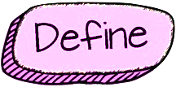 | DEFINE: Teams will review interview answers/footage and brainstorm/determine ideas regarding film genre and story.
ADST Curricular Competencies | - Choose a design opportunity  - Identify key features or potential users and their requirements  - Identify criteria for success and any constraints
ADST Content | MEDIA ARTS  - elements of media arts used to communicate meaning (Elaboration: composition, time, space, sound, movement, lighting)  - influences of digital media for the purpose of communication and self-expression  - story principles and genre conventions (Elaboration: story principles: electing and organizing the elements of structure, intent, characters, settings, and points of view within the conventions of a genre)
Additional Curriculum:  ENGLISH LANGUAGE ARTS | COMPETENCIES: COMPREHEND AND CONNECT  - Recognize and appreciate how different features, forms, and genres of texts reflect different purposes, audiences, and messages  COMPETENCIES: CREATE AND COMMUNICATE  - Exchange ideas and viewpoints to build shared understanding and extend thinking  - Use writing and design processes to plan, develop, and create engaging and meaningful literary and informational texts for a variety of purposes and audiences
Additional Curriculum:

Instruction/ Just in time learning | ​​  - Basic plots & conflicts  - How to use the graphic organizer to determine the key features from the interview  - What are genres?  - Video: Shrek but in 7 Different Genres ​ (on Media Arts 6-9 website)
Formative Assessment
Materials Needed | Media Arts 6-9 Website  - Basic plots & conflicts  - Brainstorming graphic organizer
Teacher Reflection

 | IDEATE: Teams will develop a storyline considering setting, characters, and story events. If the video includes dialogue, students will create a script based on the storyboard. Students will learn/review shot styles, angles and camera motion
ADST Curricular Competencies | - Generate potential ideas and add to others’ ideas  - Screen ideas against criteria and constraints  - Evaluate personal, social, and environmental impacts and ethical considerations  - Choose an idea to pursue
ADST Content | MEDIA ARTS  - digital and non-digital media technologies, their distinguishing characteristics, and their uses, including layout and design, graphics and images, and video production techniques for using images, sounds, and text to represent characterizations and points of view of people, including themselves, as well as settings and ideas  - story principles and genre conventions (Elaborations: genre conventions: traditional or culturally accepted ways of doing things based on audience expectations)
Additional Curriculum:  ENGLISH LANGUAGE ARTS | COMPETENCIES: COMPREHEND AND CONNECT  - Recognize how language constructs personal, social, and cultural identity  - Apply appropriate strategies to comprehend written, oral, and visual texts, guide inquiry, and extend thinking  - Synthesize ideas from a variety of sources to build understanding  - Recognize and appreciate how different features, forms, and genres of texts reflect different purposes, audiences, and messages  CONTENT: STORY/TEXT  - forms, functions, and genres of text  COMPETENCIES: CREATE AND COMMUNICATE  - Use writing and design processes to plan, develop, and create engaging and meaningful literary and informational texts for a variety of purposes and audiences
Additional Curriculum:

Instruction/ Just in time learning | Media Arts 6-9 Website  - Shot styles  - How to create a storyline  - How to write a script (not needed for an iMovie trailer)
Formative Assessment | - Share first draft of storyline with another team for feedback  - Reflective journal entry on participation
Materials Needed | Media Arts 6-9 Website  - Video examples of various genres for writing styles (under the Define heading on the website)  - Storyline  - Optional: Script writing tool (browser based)
Teacher Reflection

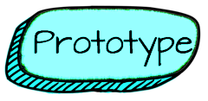 | PROTOTYPE: Teams will storyboard their storyline, including shot style, camera angle, camera person, talent.
ADST Curricular Competencies | - Identify and use sources of information  - Develop a plan that identifies key stages and resources  - Explore and test a variety of materials for effective use  - Construct a first version of the product or a prototype, as appropriate, making changes to tools, materials, and procedures as needed  - Record iterations of prototyping
ADST Content | MEDIA ARTS  - techniques for using images, sounds, and text to communicate information, settings, ideas, and story structure (Elaborations: techniques: layout, storyboard, and manipulation)
Additional Curriculum:  ENGLISH LANGUAGE ARTS | CONTENT: STORY/TEXT  - forms, functions, and genres of text  COMPETENCIES: CREATE AND COMMUNICATE  - Use writing and design processes to plan, develop, and create engaging and meaningful literary and informational texts for a variety of purposes and audiences  - Select and use appropriate features, forms, and genres according to audience, purpose,  and message  - Use and experiment with oral storytelling processes
Additional Curriculum:

Instruction/ Just in time learning | - Why storyboard
Formative Assessment | - Students reflect on the degree to which the storyboard follows the storyline
Materials Needed | - Completed storyline  Media Arts 6-9 Website  - Storyboards  - PowerPoint: Storyline & Storyboarding, grade 6-7 and 8+​
Teacher Reflection

 | TEST: The Pitch: Teams will pitch to the class (or to the people they interviewed). The class or interviewee provide feedback. Teams iterate their original plan.
ADST Curricular Competencies |  | - Test the first version of the product or the prototype  - Gather peer and/or user and/or expert feedback and inspiration  - Make changes, troubleshoot, and test again
ADST Content |  | MEDIA ARTS  - processes for manipulating and testing digital media data
Additional Curriculum:  ENGLISH LANGUAGE ARTS |  | CONTENT: LANGUAGE FEATURES, STRUCTURES, AND CONVENTIONS:  - presentation techniques  COMPETENCIES: CREATE AND COMMUNICATE  - Use writing and design processes to plan, develop, and create engaging and meaningful literary and informational texts for a variety of purposes and audiences
Additional Curriculum:

Instruction/ Just in time learning |  | - How to provide meaningful feedback
Formative Assessment |  | - Peer feedback
Materials Needed |  | Media Arts 6-9 Website  - Ideas for a Pitch  - Feedback slips for peers
Teacher Reflection

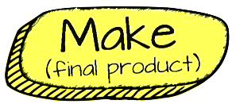 | MAKE: Teams film as per their storyboard (obtaining permission before hand where needed). Teams should rotate the camera person, and talent roles. Students will then edit with iMovie
ADST Curricular Competencies | - Identify and use appropriate tools, technologies, and materials for production  - Make a plan for production that includes key stages, and carry it out, making changes as needed  - Use materials in ways that minimize waste
ADST Content | MEDIA ARTS:  - media technologies and techniques to shape space, time, movement, and lighting within images, sounds, and text for specific purposes  - issues in ethical media practices, including cultural appropriation, moral copyright, reproduction, and privacy  COMPUTERS AND COMMUNICATIONS DEVICES:  - systems for information transfer and communication, including videos, blogs, podcasts, and social media  DIGITAL LITERACY CONTENT:  - ethical and legal implications of current and future technologies  - strategies for curating personal digital content, including management, personalization, organization, and maintenance of digital content; e-mail management; and workflow
Additional Curriculum:  ENGLISH LANGUAGE ARTS | COMPETENCIES: CREATE AND COMMUNICATE  - Use writing and design processes to plan, develop, and create engaging and meaningful literary and informational texts for a variety of purposes and audiences  - Transform ideas and information to create original texts
Additional Curriculum:
Instruction/ Just in time learning | Options (on the Media Arts 6-9 Website)  - How to use “Green Screen by Do Ink” app  - How to “Airdrop”  - How to use “Documents by Readdle” App (Importance of creative commons)  - Editing in iMovie  - Using Bounce Boards  - Using Lighting Techniques
Formative Assessment | - Individual/Team daily reflection
Materials Needed | - Film equipment  - iMovie
Teacher Reflection

 | SHARE: Student share and reflect. Sharing could be at an assembly, on the Internet or more. It is important that students have an opportunity to share their work.
ADST Curricular Competencies | - Decide on how and with whom to share their product  - Demonstrate their product and describe their process, using appropriate terminology and providing reasons for their selected solution and modifications  - Evaluate their product against their criteria and explain how it contributes to the individual, family, community, and/or environment  - Reflect on their design thinking and processes, and evaluate their ability to work effectively both as individuals and collaboratively in a group, including their ability to share and maintain an efficient co-operative work space  - Identify new design issues
ADST Content | DIGITAL LITERACY  - methods for personal media management
Additional Curriculum:  ENGLISH LANGUAGE ARTS | CONTENT: LANGUAGE FEATURES, STRUCTURES, AND CONVENTIONS:  - presentation techniques  COMPETENCIES: CREATE AND COMMUNICATE  - Use writing and design processes to plan, develop, and create engaging and meaningful literary and informational texts for a variety of purposes and audiences
Additional Curriculum:

Instruction/ Just in time learning | - How to share to shareable space
Formative Assessment | Media Arts 6-9 Website  - Core Competencies Final Reflection
Materials Needed | - Log in to shareable space  - Discuss appropriate & private strategies for sharing and story media
Teacher Reflection

