ADST 6-7 Unit Overview
Teacher Name:
 | Curricular Competencies | Media Arts/__________ Curriculum | Instruction/Just in time learning | Formative Assessment
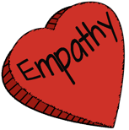  Understanding context | Empathize with potential users to find issues and uncover needs and potential design opportunities
Choose a design opportunity
Identify key features or potential users and their requirements
Identify criteria for success and any constraints
Generate potential ideas and add to others’ ideas
Screen ideas against criteria and constraints
Evaluate personal, social, and environmental impacts and ethical considerations
Choose an idea to pursue
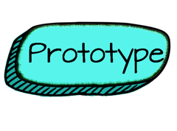 | Identify and use sources of information  Develop a plan that identifies key stages and resources  Explore and test a variety of materials for effective use  Construct a first version of the product or a prototype, as appropriate, making changes to tools, materials, and procedures as needed  Record iterations of prototyping
Test the first version of the product or the prototype
Gather peer and/or user and/or expert feedback and inspiration
Make changes, troubleshoot, and test again
Identify and use appropriate tools, technologies, and materials for production
Make a plan for production that includes key stages, and carry it out, making changes as needed
Use materials in ways that minimize waste
Decide on how and with whom to share their product
Demonstrate their product and describe their process, using appropriate terminology and providing reasons for their selected solution and modifications
Evaluate their product against their criteria and explain how it contributes to the individual, family, community, and/or environment
Reflect on their design thinking and processes, and evaluate their ability to work effectively both as individuals and collaboratively in a group, including their ability to share and maintain an efficient co-operative work space
Identify new design issues

