Topic: STEAM: Creating an Informational Video
Descriptor: Teams of students created Bill Nye type informational videos for the grade 2’s.
Teacher Name: Kim Gammel & Kavita Hoonjan
School: James Kennedy elementary
Grade: 6

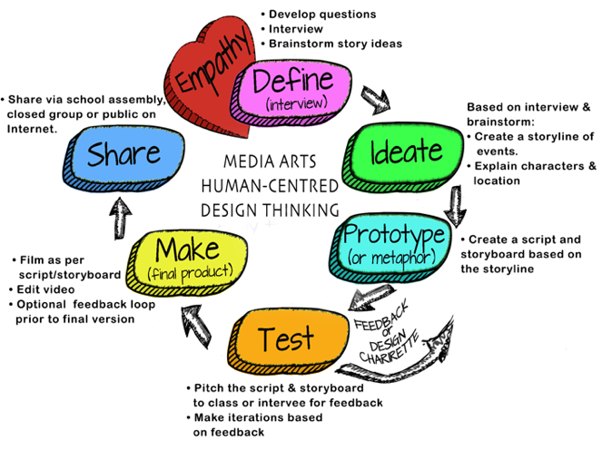
How will you work on building Collaborative Teams?
- Media Arts 6-9 webpage:
  - Media Arts Team Roles (all team members will be involved with the storyline, script, storyboard, filming & editing). View the for possible team roles, based on a team of 3. File:
  - Team Contracts and Project Management Logs

ADST Curricular Competencies interwoven throughout:
Applied Skills
- Demonstrate an awareness of precautionary and emergency safety procedures in both physical and digital environments
- Identify and evaluate the skills and skill levels needed, individually
or as a group, in relation to a specific task, and develop them as needed

Applied Technologies
- Select, and as needed learn about, appropriate tools and technologies to extend their capability to complete a task
- Identify the personal, social, and environmental impacts, including unintended negative consequences, of the choices they make about technology use
- Identify how the land, natural resources, and culture influence the development and use of tools and technologies

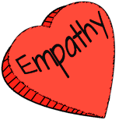 | EMPATHY: Understanding Context. Deciding who to interview depends on the intent of the video. Is the video created ABOUT a person or group? (they are the content) or FOR a person or group? (they are the audience)
ADST Curricular Competencies | - Empathize with potential users to find issues and uncover needs and potential design opportunities  - Elaborations: share the feelings and understand the needs of others to inform design
Additional Curriculum:  ENGLISH LANGUAGE ARTS | COMPETENCIES: COMPREHEND AND CONNECT  - Access information and ideas for diverse purposes and from a variety of sources and evaluate their relevance, accuracy, and reliability  COMPETENCIES: CREATE AND COMMUNICATE  - Use writing and design processes to plan, develop, and create engaging and meaningful literary and informational texts for a variety of purposes and audiences
Additional Curriculum:  SCIENCE | - Demonstrate a sustained curiosity about a scientific topic or problem of personal interest  - Make observations in familiar or unfamiliar contexts  - Identify questions to answer or problems to solve through scientific inquiry  - Make predictions about the findings of their inquiry
Instruction/ Just in time learning | - Developing interview questions
Formative Assessment | - Teacher observations of progress  - Students shared with the larger group the results of their interviews/presentations
Materials Needed | Following handout: STEAM: Creating Informational Video outline for students  • Reflection: Human Centred Design Thinking Process (give the final assessment. Review the definitions for clarity!  Media Arts 6-9 Website: Questioning/Interviewing
Teacher Reflection | - It was very informative and helpful to the students to have gone to their respective grade 2 classes. After having pitched their ideas, they asked what the students were most interested in and this feedback guided their final choice. Interaction with the younger students also allowed the Gr. 5s to better understand at what level the language and content should be to be comprehensible and educational for their target audience.

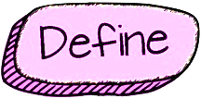 | DEFINE: Teams will review interview answers/footage and brainstorm/determine ideas regarding film genre and story.
ADST Curricular Competencies | - Choose a design opportunity  - Identify key features or potential users and their requirements  - Identify criteria for success and any constraints
ADST Content | MEDIA ARTS  - influences of digital media for the purpose of communication and self-expression
Additional Curriculum:  ENGLISH LANGUAGE ARTS | COMPETENCIES: COMPREHEND AND CONNECT  - Understand how literary elements, techniques, and devices enhance and shape meaning  COMPETENCIES: CREATE AND COMMUNICATE  - Use writing and design processes to plan, develop, and create engaging and meaningful literary and informational texts for a variety of purposes and audiences
Instruction/ Just in time learning | ​​  - Basic plots & conflicts  - How to use the graphic organizer to determine the key features from the interview  - What are genres?  - Video: Shrek but in 7 Different Genres ​ (on Media Arts 6-9 website)
Formative Assessment | - Teacher observations  - Peer discussion and feedback
Materials Needed | Media Arts 6-9 Website  - Basic plots & conflicts  - Brainstorming graphic organizer
Teacher Reflection | - Students were better able to finalize their plans based on feedback from the presentations to their primary classes. Camera angles as well as how best to divide their iMovie “lesson” into comprehensible steps were well-informed.

 | IDEATE: Teams will develop a storyline considering setting, characters, and story events. If the video includes dialogue, students will create a script based on the storyboard. Students will learn/review shot styles, angles and camera motion
ADST Curricular Competencies | - Generate potential ideas and add to others’ ideas  - Screen ideas against criteria and constraints  - Evaluate personal, social, and environmental impacts and ethical considerations  - Choose an idea to pursue
ADST Content  MEDIA ARTS | - digital and non-digital media, and their distinguishing characteristics and uses
Additional Curriculum:  ENGLISH LANGUAGE ARTS | COMPETENCIES: COMPREHEND AND CONNECT  - Recognize and appreciate the role of story, narrative, and oral tradition in expressing First Peoples perspectives, values, beliefs, and points of view  - Select and use appropriate features, forms, and genres according to audience, purpose, and message  - Use and experiment with oral storytelling processes  CONTENT: STORY/TEXT: • forms, functions, and genres of text  COMPETENCIES: CREATE AND COMMUNICATE  - Use writing and design processes to plan, develop, and create engaging and meaningful literary and informational texts for a variety of purposes and audiences
Additional Curriculum:  SCIENCE | - Communicate ideas, explanations, and processes in a variety of ways
Instruction/ Just in time learning | Media Arts 6-9 Website  - Shot styles  - How to create a storyline  - How to write a script (not needed for an iMovie trailer)
Formative Assessment | - Share first draft of storyline with another team for feedback  - Reflective journal entry on participation
Materials Needed | Media Arts 6-9 Website  - Video examples of various genres for writing styles (under the Define heading on the website)  - Storyline • Optional: Script writing tool (browser based)
Teacher Reflection | - This step takes time and allows for students to break into parts the targeted final product. For a first-time experience, the students demonstrated fair to good understanding of the process of storyboarding. Further experience and practice will help to refine these skills.

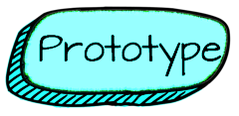 | PROTOTYPE: Teams will storyboard their storyline, including shot style, camera angle, camera person, talent.
ADST Curricular Competencies | - Identify and use sources of information  - Develop a plan that identifies key stages and resources  - Explore and test a variety of materials for effective use  - Construct a first version of the product or a prototype, as appropriate, making changes to tools, materials, and procedures as needed  - Record iterations of prototyping
ADST Content  MEDIA ARTS | - techniques for using images, sounds, and text to communicate information, settings, ideas, and story structure
Additional Curriculum:  ENGLISH LANGUAGE ARTS | - COMPETENCY: Select and use appropriate features, forms, and genres according to audience, purpose,  and message  - COMPETENCY: Use and experiment with oral storytelling processes
Additional Curriculum:  SCIENCE | - Communicate ideas, explanations, and processes in a variety of ways
Instruction/ Just in time learning | - Why storyboard
Formative Assessment | - Students reflect on the degree to which the storyboard follows the storyline
Materials Needed | - Completed storyline  Media Arts 6-9 Website  - Storyboards  - Storyline & Storyboarding, grade 6-7 and 8+​
Teacher Reflection | This step takes time and allows for students to break into parts the targeted final product. For a first-time experience, the students demonstrated fair to good understanding of the process of storyboarding. Further experience and practice will help to refine these skills.

 |  | TEST: The Pitch: Teams will pitch to the class (or to the people they interviewed). The class or interviewee provide feedback. Teams iterate their original plan.
ADST Curricular Competencies | - Test the first version of the product or the prototype  - Gather peer and/or user and/or expert feedback and inspiration  - Make changes, troubleshoot, and test again
Additional Curriculum:  ENGLISH LANGUAGE ARTS | CONTENT: LANGUAGE FEATURES, STRUCTURES, AND CONVENTIONS  - presentation techniques
Additional Curriculum:  SCIENCE | - Communicate ideas, explanations, and processes in a variety of ways
Instruction/ Just in time learning | - How to provide meaningful feedback
Formative Assessment | - Peer feedback
Materials Needed | Media Arts 6-9 Website  - Ideas for a Pitch  - Feedback slips for peers

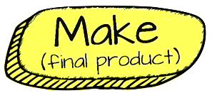 | MAKE: Teams film as per their storyboard (obtaining permission before hand where needed). Teams should rotate the camera person, and talent roles. Students will then edit with iMovie
ADST Curricular Competencies | - Identify and use appropriate tools, technologies, and materials for production  - Make a plan for production that includes key stages, and carry it out, making changes as needed  - Use materials in ways that minimize waste
ADST Content | MEDIA ARTS:  - techniques for using images, sounds, and text to communicate information, settings, ideas, and story structure  DIGITAL LITERACY CONTENT:  - legal and ethical considerations, including creative credit and copyright, and cyberbullying
Additional Curriculum:  ENGLISH LANGUAGE ARTS | COMPETENCIES: CREATE AND COMMUNICATE  - Use writing and design processes to plan, develop, and create engaging and meaningful literary and informational texts for a variety of purposes and audiences  - Transform ideas and information to create original texts
Instruction/ Just in time learning | Options (on the Media Arts 6-9 Website)  - How to use “Green Screen by Do Ink” app  - How to “Airdrop”  - How to use “Documents by Readdle” App (Importance of creative commons)  - Editing in iMovie
Formative Assessment | - Individual/Team daily reflection
Materials Needed | - Film equipment  - iMovie
Teacher Reflection | This step also requires time and there is much in the way of trouble shooting and learning through errors, doing retakes, working within time limits and figuring out microphones, how iMovie works, etc. Having an expert on hand to help with the trouble shooting was invaluable. After this experience, the students have become more adept and will be better able to work through the process again in the future.

 | SHARE: Student share and reflect. Sharing could be at an assembly, on the Internet or more. It is important that students have an opportunity to share their work.
ADST Curricular Competencies | - Decide on how and with whom to share their product  - Demonstrate their product and describe their process, using appropriate terminology and providing reasons for their selected solution and modifications  - Evaluate their product against their criteria and explain how it contributes to the individual, family, community, and/or environment  - Reflect on their design thinking and processes, and evaluate their ability to work effectively both as individuals and collaboratively in a group, including their ability to share and maintain an efficient co-operative work space  - Identify new design issues
ADST Content | DIGITAL LITERACY:  - methods for personal media management
Additional Curriculum:  ENGLISH LANGUAGE ARTS | CONTENT: LANGUAGE FEATURES, STRUCTURES, AND CONVENTIONS:  - presentation techniques  COMPETENCIES: CREATE AND COMMUNICATE  - Use writing and design processes to plan, develop, and create engaging and meaningful literary and informational texts for a variety of purposes and audiences
Additional Curriculum:  SCIENCE | - Communicate ideas, explanations, and processes in a variety of ways
Instruction/ Just in time learning | - How to share to a shareable space (how & where to share the video)
Formative Assessment | Media Arts 6-9 Website  - Core Competencies Final Reflection  - Reflection: Human Centred Design Thinking Process
Materials Needed | - Log in to shareable space  - Discuss appropriate & private strategies for sharing and story media
Teacher Reflection | - Students shared their videos with their primary classroom audiences as well as with each other as a collective. They were proud, embarrassed and shy about their final products. They had fun watching the videos and were able to speak to what was effective as well as being able to provide constructive feedback for improvements. This was a true celebration of the journey to the final product.

